**iQ Media Corporate Website**

**Stop-Gap Updates – August 2012**

**Resources Page**

Headline:

White Papers

Copy:

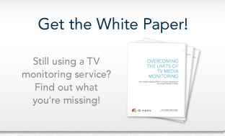**Overcoming the Limits of TV Media Monitoring**

Learn why a media intelligence platform is the new must-have technology for organizations with a message to promote or a brand to protect.

Headline:

Product Literature

Copy: (in every case we’d like the button to invoke the resource as is does on the other pages):

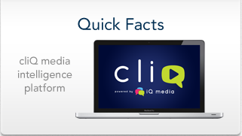Pressed for time? Here are the key facts about cliQ on a single sheet of paper (well, we did use both sides).

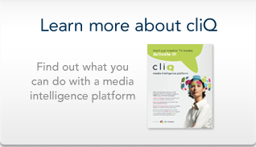

cliQ is a media research platform for that empowers organizations to leverage broadcast media content in ways that were not possible until now. This four-page brochure gives you an introduction to cliQ.

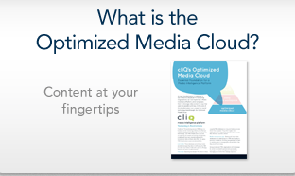cliQ’s Optimized Media Cloud is a software technology breakthrough, delivering high quality content to your desktop, smartphone, or tablet.

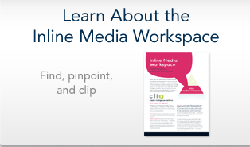Tracking media is no good unless you can do something with it. cliQ provides a complete Inline Media Workspace that maximizes your return on time spent.



To really leverage media content, you need an Enterprise Media Center. My iQ gives you the power to share, manage, and leverage the content that is most important to your organization’s strategic goals.